# J.V.C. ten Berge

N. Joosen

E.J.M. Snoeren

V. van Oorschot

*huisartsen*

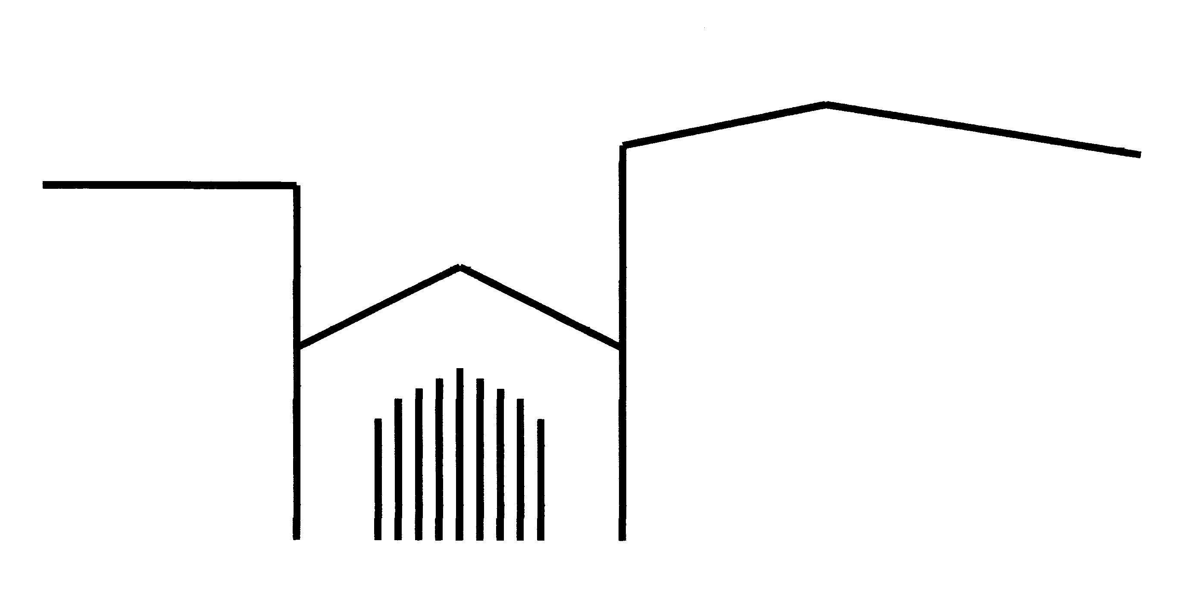



Huisartsenpraktijk “t Weeshuis”

Begijnenstraat 29

6511 WN Nijmegen

tel.: 024-3228380

IBAN: NL63ABNA0575223103

[info@hapweeshuis.nl](mailto:info@hapweeshuis.nl)

www.hapweeshuis.nl

**APPLICATION FORM; INSPECTION, COPY, CORRECTION OR DESTRUCTION OF MEDICAL DATA**

**Patient information**

|  |  |
| --- | --- |
| Sure name and initials: |  |
| Maiden name: |  |
| Birthdate: |  |
| Address: |  |
| Postal code and city: |  |
| Telephone (private or mobile): |  |
| E-mail address: |  |

***Only complete requested information below if the applicant is an other person than the patient (this is only permitted for children under the age of 16):***

|  |  |
| --- | --- |
| *Name applicant:* |  |
| *Relation to patient:* |  |
| *Address:* |  |
| *Postal code and city:* |  |
| Telephone (private or mobile): |  |
| E-mail address: |  |

**Request for:**

* Insight to medical file
* A copy of the medical file in PDF; file via Zorgmail (secured)
* Correction of the objective data in the medical file
* Destruction of medical data from the medical file
* Destruction phone call recording

It concerns data on treatment at (general practitioner, practice assistant, etc.):

……………………………………..

Treatment took place in the period(s):.........................................................................................

If the request only concerns certain information, what part of information does it concern?

.....................................................................................................................................................

Reason for request:

……………………………………………………………………………………………………………..

Signature patient / applicant (strike out what is not applicable):

City: ......................... Date: ..................................

Signature ............................................................................................................................

Identification document registration number: .............................................................

**Please take the application form to the practice and your identificationdocument(s) so that we can verify your identity.**